SIMATS ENGINEERING
ASSESSMENT TOOL 3

COURSE NAME: Database Management Systems
COURSE CODE: CSA0504
COURSE OUTCOME COVERED
CO3: Analyze relational databases using functional dependencies, normalization (1NF
to 5NF), and key constraints to identify redundancy and ensure data integrity. (BL2,
BL3)
Activity Tool : MCQ Test (Low)
Assessment Tool Weightage: 30%
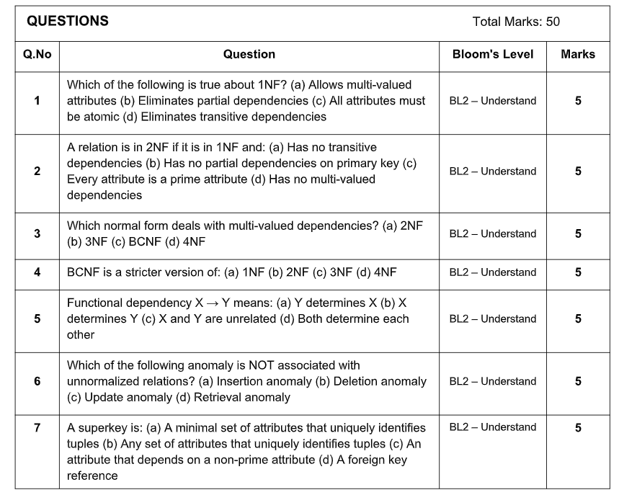

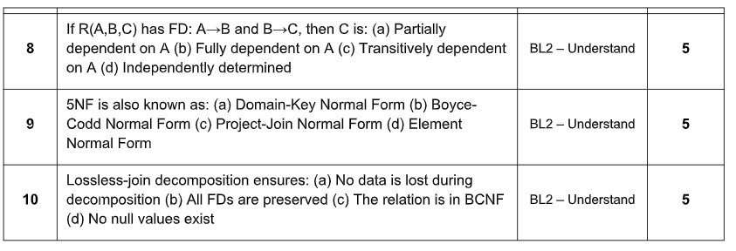
Code of Conduct:
I Shaik Mahamad Sohail (192511120) certify that this submission is my original
work and that I have adhered to the guidelines specified for this assessment.
I understand that any violation of academic integrity rules will result in disciplinary
action.

Signature of the student: 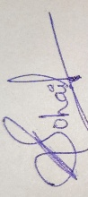

1. Which of the following is true about 1NF?
(a) Allows multi-valued attributes
(b) Eliminates partial dependencies
(c) All attributes must be atomic
(d) Eliminates transitive dependencies
Ans : c) All attributes must be atomic

2. A relation is in 2NF if it is in 1NF and:
(a) Has no transitive dependencies
(b) Has no partial dependencies on primary key
(c) Every attribute is a prime attribute
(d) Has no multi-valued dependencies
Ans : (b) Has no partial dependencies on primary key

3. Which normal form deals with multi-valued dependencies?
(a) 2NF
(b) 3NF
(c) BCNF
(d) 4NF
Ans : (d) 4 NF

4. BCNF is a stricter version of:
(a) 1NF
(b) 2NF
(c) 3NF
(d) 4NF
Ans : (c) 3NF

5. Functional dependency X → Y means:
(a) Y determines X
(b) X determines Y
(c) X and Y are unrelated
(d) Both determine each other
Ans : (b) X determines Y

6. Which of the following anomaly is NOT associated with
unnormalized relations?
(a) Insertion anomaly
(b) Deletion anomaly
(c) Update anomaly
(d) Retrieval anomaly
Ans : (d) Retrieval anomaly

7. A superkey is:
(a) A minimal set of attributes that uniquely identifies tuples
(b) Any set of attributes that uniquely identifies tuples
(c) An attribute that depends on a non-prime attribute
(d) A foreign key reference
Ans : (b) Any set of attributes that uniquely identifies tuples

8. If R(A,B,C) has FD: A→B and B→C, then C is:
(a) Partially dependent on A
(b) Fully dependent on A
(c) Transitively dependent on A
(d) Independently determined
Ans : (c) Transitively dependent on A

9. 5NF is also known as:
(a) Domain-Key Normal Form
(b) Boyce- Codd Normal Form
(c) Project-Join Normal Form
(d) Element Normal Form
Ans : (c) Project-Join Normal Form

10. 5NF is also known as:
(a) Domain-Key Normal Form
(b) Boyce- Codd Normal Form
(c) Project-Join Normal Form
(d) Element Normal Form
Ans : (a) Domain-Key Normal Form

